**Registering for Microsoft ELMS for DreamSpark Software (2016-2017)**

Math & Computer Science Department – Webster University

Students currently enrolled in one of the Math & Computer Science department’s computing courses in St. Louis may download a variety of free Microsoft software via the department’s ELMS for DreamSpark web store.

Students must be registered and validated in order to download software. Your instructor will request an account for each student.

Examples include:

**Windows 7 / 8 / 10 Visual Studio Project Access Visio Streets & Trips etc.**

1) Visit the department’s ELMS for DreamSpark web store**:**

<http://mercury.webster.edu/wang/msdnaa/>

then select from the list:

[MSDN Academic Alliance - Microsoft ELMS for DreamSpark Software WebStore](https://e5.onthehub.com/WebStore/ProductsByMajorVersionList.aspx?ws=1b450ba8-4bb9-e411-9408-b8ca3a5db7a1)

2) Click on “Register” in the upper right hand corner of the screen:

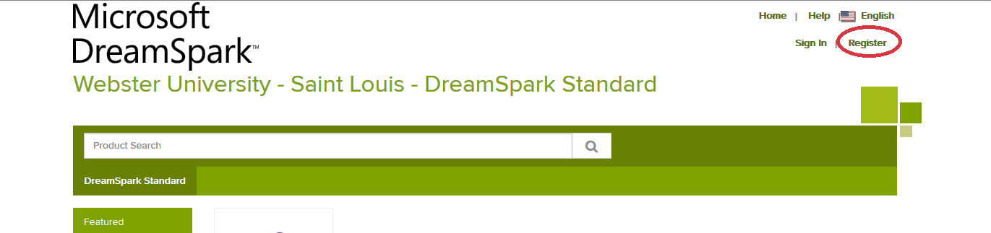

3) You will then receive an email in your official Webster email account with further instructions. (Check your junk folder)

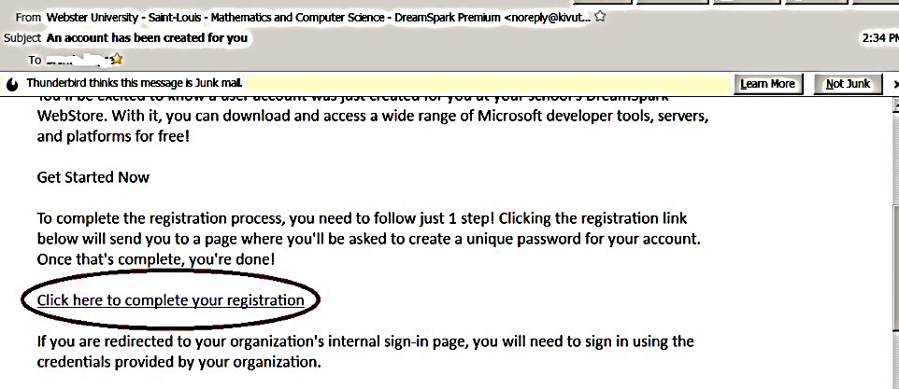

4) Open the email and click on the link to complete your registration.

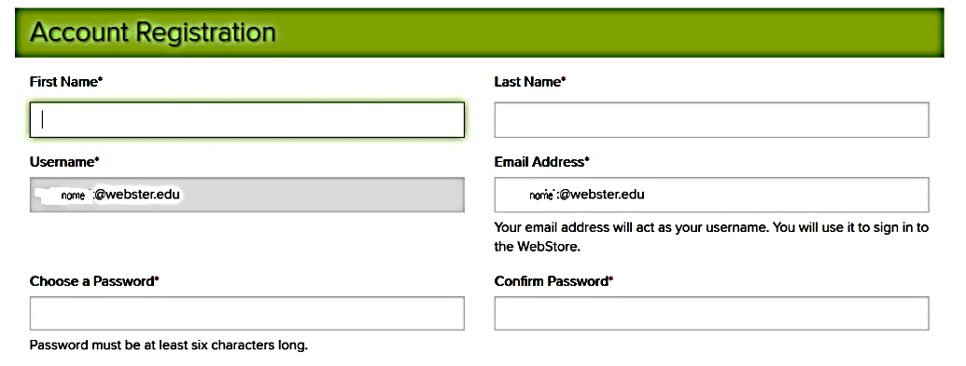

5) Enter your first and last name, choose and confirm a password (eg your connections password).

Type the requested text, and select “register”

6) After you see the message that registration has been successfully completed, choose the “Home” link in the upper right hand corner.

7) Proceed to the Download Procedures on the next page.

**Download Instructions for Visual Studio 2013 from MSDN-AA Webster University**

**\*\* You will need to carefully follow the directions in this document to be successful. \*\***

1) Make sure that you have completed the registration procedures (pages 1 - 2)

2) You may need a blank DVD with capacity of at least 2.8 GB to complete this process.

3) If you signed out after completing registration, follow the procedures on page 6 to sign back in.

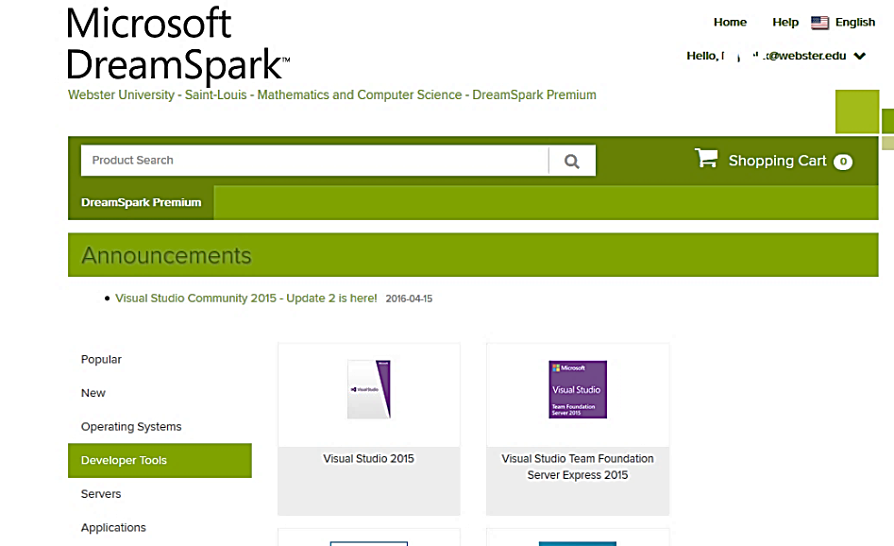4) Select “Developer Tools” from the menu options.

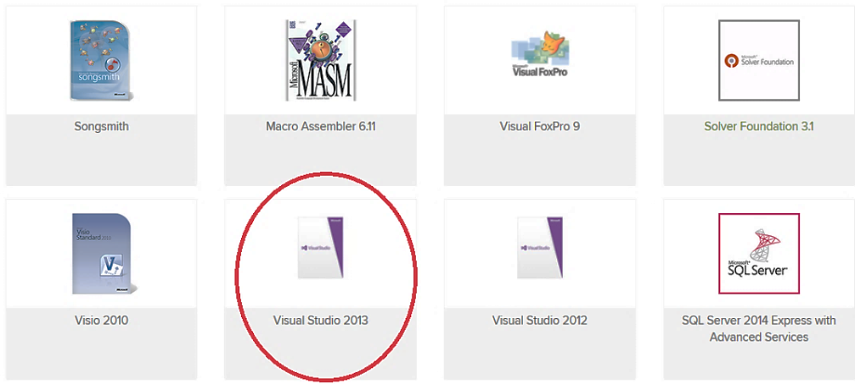

5) Then scroll down to select “Visual Studio **2013**” (do NOT choose 2015)

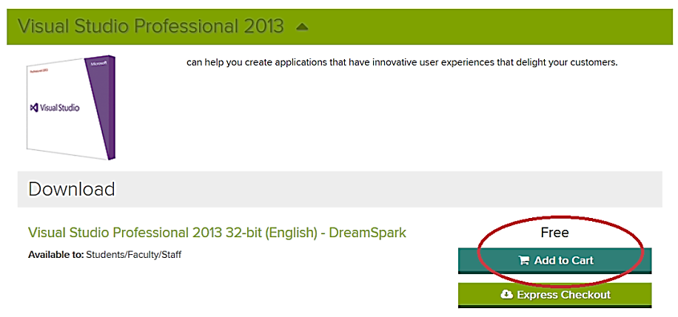6) Add “Visual Studio Professional 2013 32-bit (English)” to the cart.

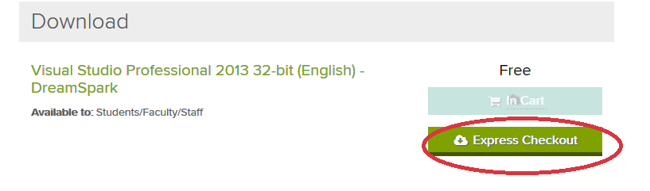

7) Click on the “Express Checkout” button.

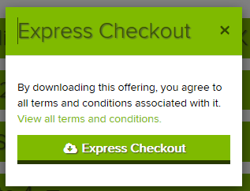

8) Read and “accept” the agreement by clicking on the next “Express Checkout” button.

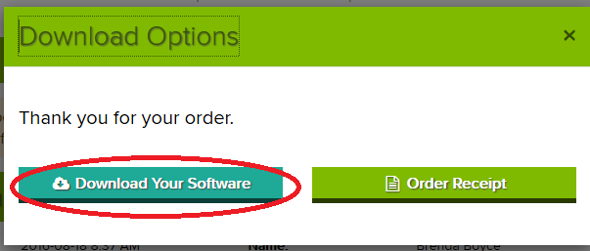

9) Click on the “Download Your Software” button.

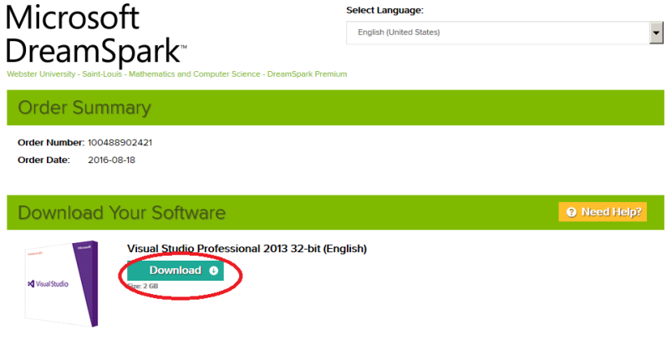10) Click on the ”Download” button

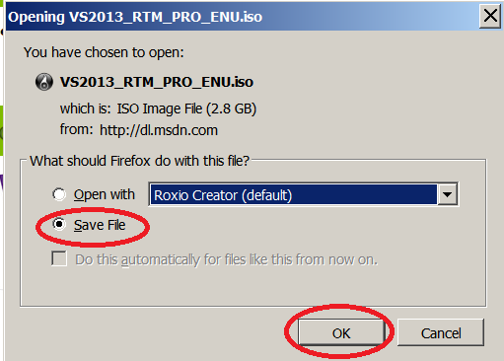

11) Save the ISO image file in location where you will be able to find it later.

** Steps 12 – 15 will be skipped, if your machine does not have a DVD drive.**

12) If you do not already have an application to burn files onto a DVD, you will need to download a freeware version. You can use any application of your choice to burn a DVD.

Directions for a suitable freeware application can be found at:

http://mercury.webster.edu/wang/msdnaa/How_to_Burn_an_IMG_File.pdf

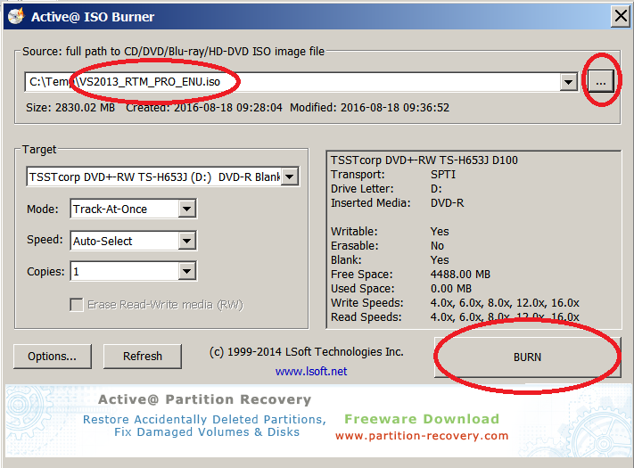

13) Insert a blank DVD into the drive on your computer. This DVD must have a capacity of at least 2.8 GB.

Browse for the ISO image file that you saved in step 11.

Click on “BURN”.

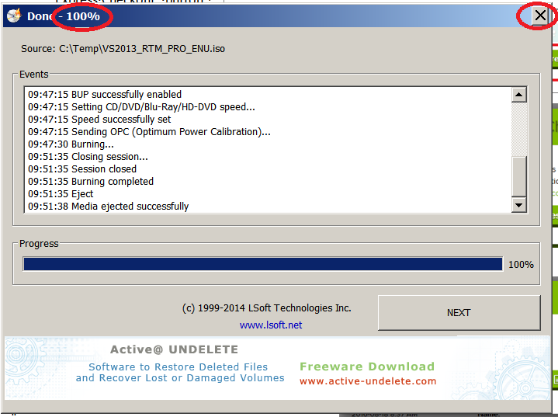

14) When the burning process is complete, the DVD drive will eject.

Click the X at the top of the window to close the program.

You now have a copy of the software and are ready to install it.

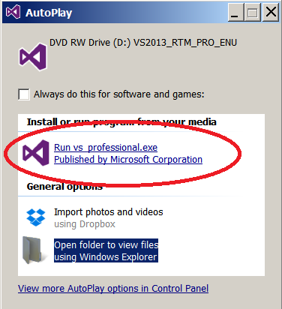

15) Re-insert the DVD disk into the drive on your computer.

Click on “Run VS Professional.exe”

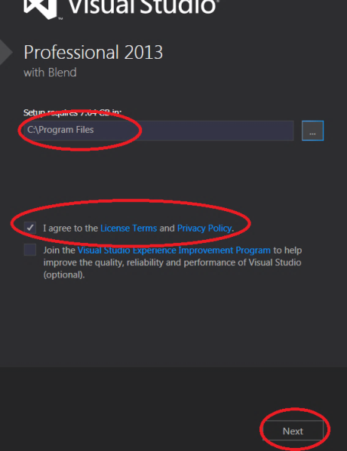16) Read and agree to

the License Terms.

Click on “Next”.

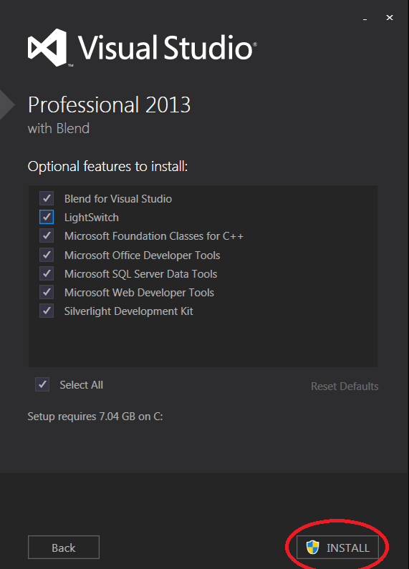17) Select “INSTALL”

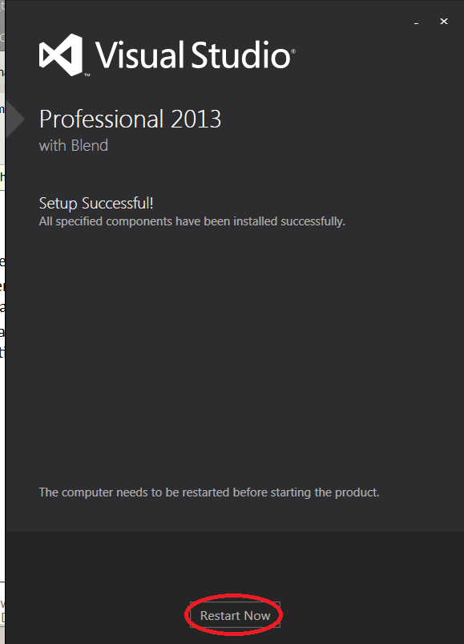

18) Be patient! The install can take quite a bit of time.

When the setup successfully completes, click “Restart Now”.

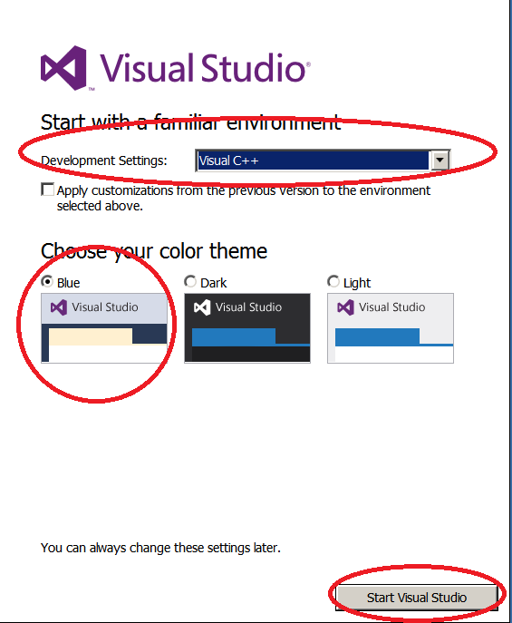19) After your computer restarts, find “Visual Studio 2013” in your list of programs.

Select the application program (purple infinity symbol”.

When the program opens the first time, you will need to choose the environment settings.

Development setting: Visual C++

Color theme: Blue (if you want to match the lab)

Click on “Start Visual Studio”

You have successfully completed the installation of Visual Studio 2013.

= = = = = = = = = = = = = = = = = = = = = = = = = = = = = = = = = = = = = =

The following steps illustrate the sign in process for access if you have already registered:.

1) Visit the department’s ELMS for DreamSpark web store**:**

<http://mercury.webster.edu/wang/msdnaa/>

then select from the list:

[MSDN Academic Alliance - Microsoft ELMS for DreamSpark Software WebStore](https://e5.onthehub.com/WebStore/ProductsByMajorVersionList.aspx?ws=1b450ba8-4bb9-e411-9408-b8ca3a5db7a1)

2) Choose “Sign-In.”

3) You may now return to step 4 on page 3 of this document.